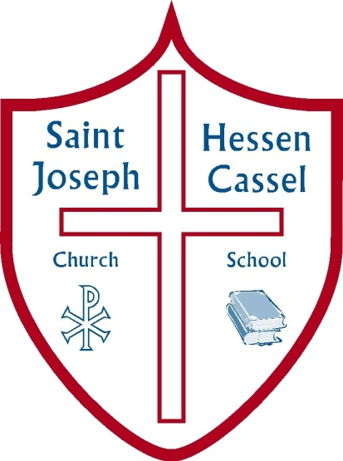
St Joseph Hessen Cassel
Financial Aid Night
Thursday, January 11th @ 6:30 pm
8th Grade Classroom
Learn information about Indiana School Choice, Scholarship Grant Organization (SGO), Tuition Assistance, FACTS Grant and Aid Application and FACTS Tuition Management. You may be surprised by what you learn!

