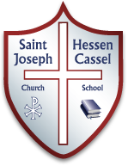 Homan Happenings
Mr. Homan’s 5th Grade Classroom
Happy Thanksgiving!!  -Mr. Homan  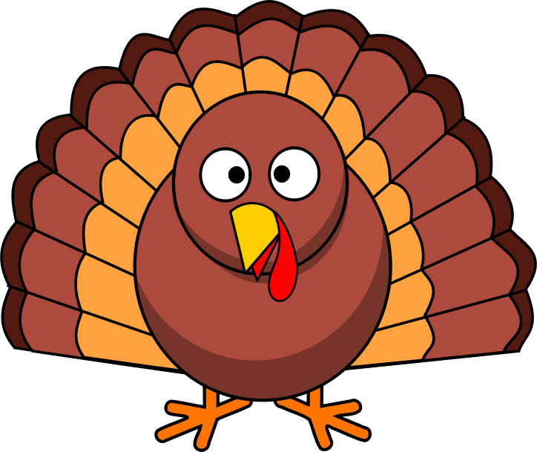  Vol. 2 Issue 14  November 20, 2017  khoman@stjoehc.org  Learning for life, living the faith.  ***Important Info***  - Family History Project: I loved hearing about the family history of each student. The displays look amazing!!  - Cooper Naatz and Shelby Hanson were the top two 5th graders in the Geography Bee. They will compete in the School Geography Bee Wednesday, November 23rd.  - I can’t wait to meet Grandparents this week. Mass is at 12:30 and this year Grandparents will visit classrooms.  Conner Prairie  We will be taking our 5th grade trip to Conner Prairie on Thursday, May 17th. I’ve taken my classes to Conner Prairie for the last ten years. I have found that if we extend the day, the kids get to experience a lot more.  So, I am proposing that we not return to St. Joe until 7:00 PM on this day. I know this may interfere with sports for that night, but I strongly encourage that students miss that night’s practice or game.  Please let me know if you have any objections to this proposal.  We use funds during a Bake Sale to pay for this field trip. To avoid the holidays, I think we will conduct this Bake Sale in January or February.  Upcoming Week  - Grandparents Day  Wednesday 11/23  - Thanksgiving Break  Thursday & Friday  11/24 & 11/25  No Band this week  All my newsletters are archived on the school website. Also, check out pictures from BizTown. Go to http://stjoehc.org/school/academics/5th-grade/  Please send me an email or sign and return this newsletter to confirm you received this.  Sign: ____________________________  Spelling:  No Spelling this week. | What we are learning:  With only three days this week we won’t be in a normal routine.  We will continue to study the Eucharist in Religion. I hope to complete the chapter on Wednesday.  We will also continue to learn about the American Revolution as we watch the Liberty’s Kids videos. We will also read more about Thanksgiving. I’ve found some Kahoot games for the kids to play as well as some Readers’ Theatre plays for the students to read in class.  We will continue to read from our novel The Report Card. I think the class is really enjoying this book.  We will also spend these three days working on Moby Max to pinpoint and work on skills in Grammar and math that each student needs to work on. This is a great tool for students that are ready to move beyond 5th grade skills and for those that need to review skills from earlier grades.

